**PHP Cake Implementation**

**Installation of composer**

<https://github.com/composer/windows-setup/releases/>

**Look for Composer-Setup 6.2.0 then install (the prompt will ask to default create folder, Press Y)**

**Creating Project**

1. Go to command prompt then cd xampp\htdocs

**Type this command: composer create-project --prefer-dist cakephp/app demo**

**Set Folder Permissions ? (Default to Y) [Y,n]? y**

check the page: localhost\demo\

check the database

1. if some issues going on, open XAMPP Control Panel look for Apache Button then click **config** button then look for **php.ini**

**Look for this extension=Intl; then remove semi-colon**

1. ***To use cakephp your php version must be 7.2 above to check the php version go to cmd and type this “php -v”***
2. Now you can try to use your cakephp project in any browser just type “localhost/demo” but before doing this make sure you have xampp installed to your computer and start the apache and mysql.

If you see this your cakephp project is created successfully

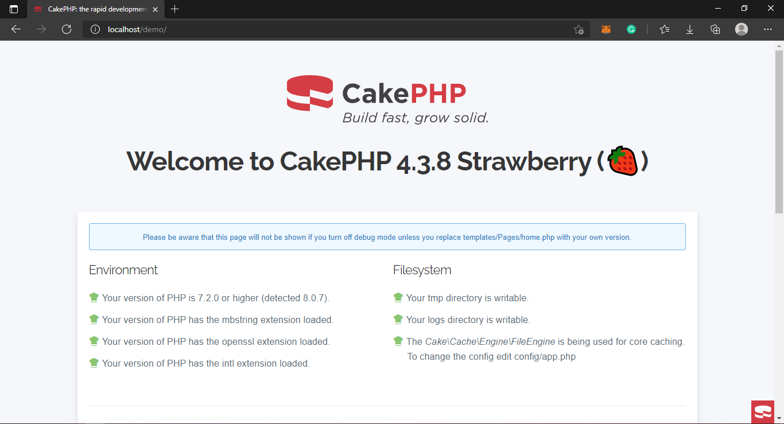

1. **Connecting cakephp to your database**

create database in phpmyadmin

database: DB_demo

1. **Creating Tables in your database**

**Table: users**

id int 11 ***auto_increment*** Primary key

name varchar (256)

email varchar (256)

password varchar (256)

address varchar (256)

created datetime

modified datetime

**Table: posts**

id int 11 auto_increment pri. key

title varchar (256)

body varchar (256)

user_id varchar(256)

created datetime

modified datatime

1. After you created a database to your phpMyAdmin, open sublime then click **File** then **Open Folder** then change the folder to XAMPP/htdocs/demo/config drag and drop the folder of your cakephp project as shown in the picture this is for sublime then look for app_local.php

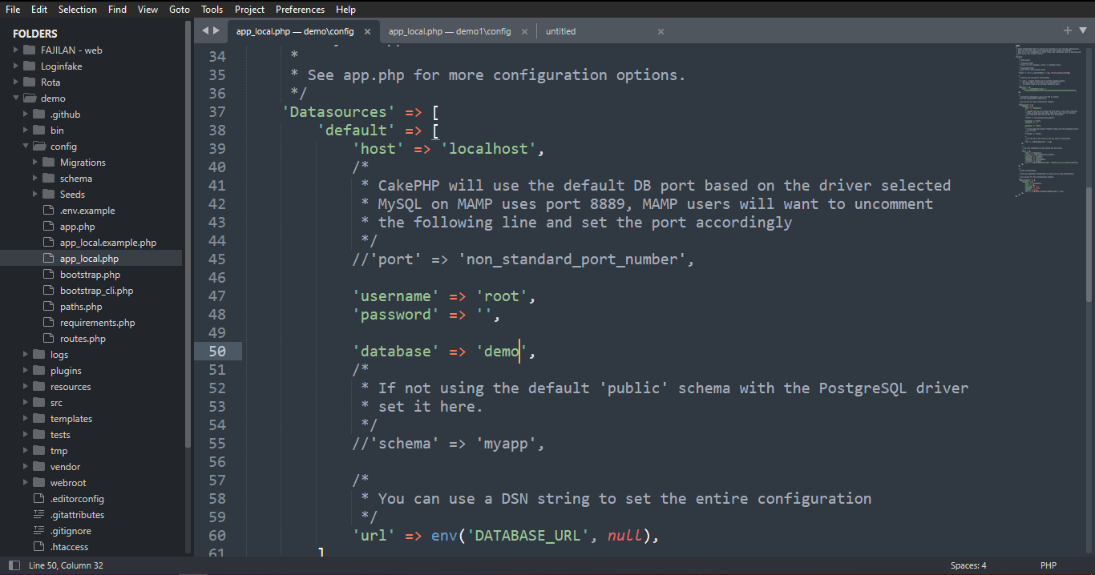

**Change the database connection**

Modify the **app_local.php**, change the setting look for xampp/htdocs/demo/**config/**app_local.php

username: change from my_app to 'root'

password: secret to ''

Database Name: change from my_app to ‘demo

1. ***Check your database connection from your web browser type: localhost/demo/***

***(logo has been changed to check)***

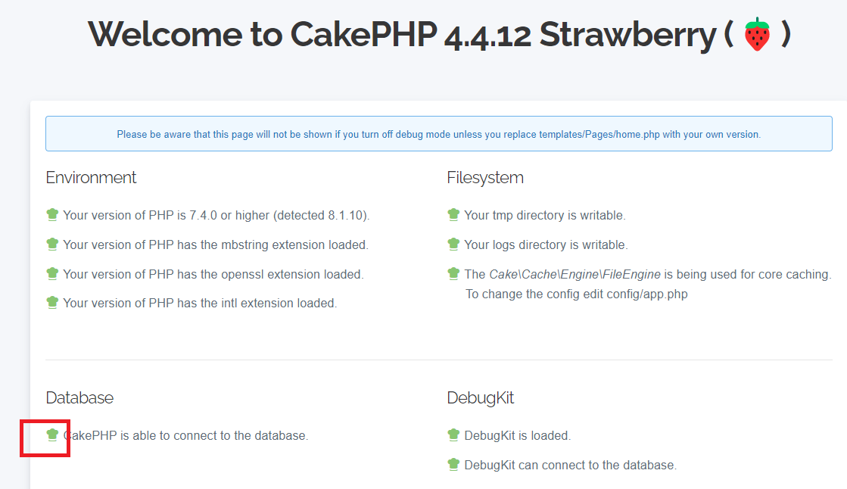

1. Connect the database structure

change folder xampp/htdocs/demo/bin

**Type this command: cake bake all users**

**Type this command: cake bake all posts**

1. Run the program: type the following at your browser for the output

**localhost/demo/users**

**localhost/demo/posts**

To change the control input type: look for **templates/users/add.php (users is a sample database table)**

Modify this area

**== sample controls for Radio Button**

echo $this->Form->control('email');

echo $this->Form->control('password');

echo $this->Form->control('address',

array('type' => 'radio','options'=>[

['value'=>'Caloocan', 'text'=>'Caloocan'],

['value'=>'Manila', 'text'=>'Manila'],

])

);

=== another control

<?php

echo $this->Form->control('name');

echo $this->Form->control('email');

echo $this->Form->control('address', array('type' => 'select','options'=>[

['value'=>'Caloocan', 'text'=>'Caloocan'],

['value'=>'Malabon', 'text'=>'Malabon'],

])

);

?>

Other types look for this link

<https://book.cakephp.org/4/en/views/helpers/form.html>